**Login**

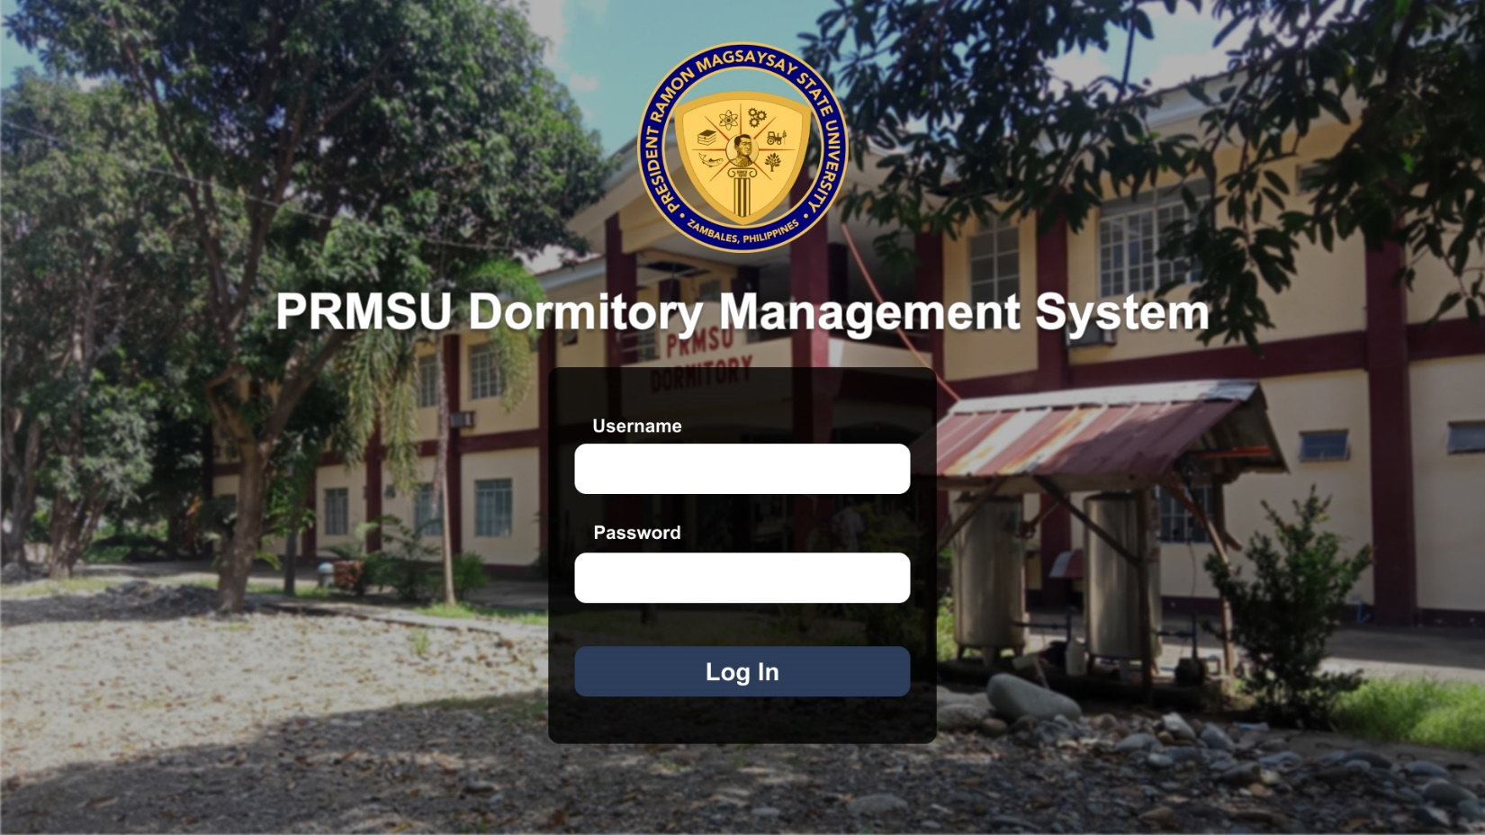

**Home Page**

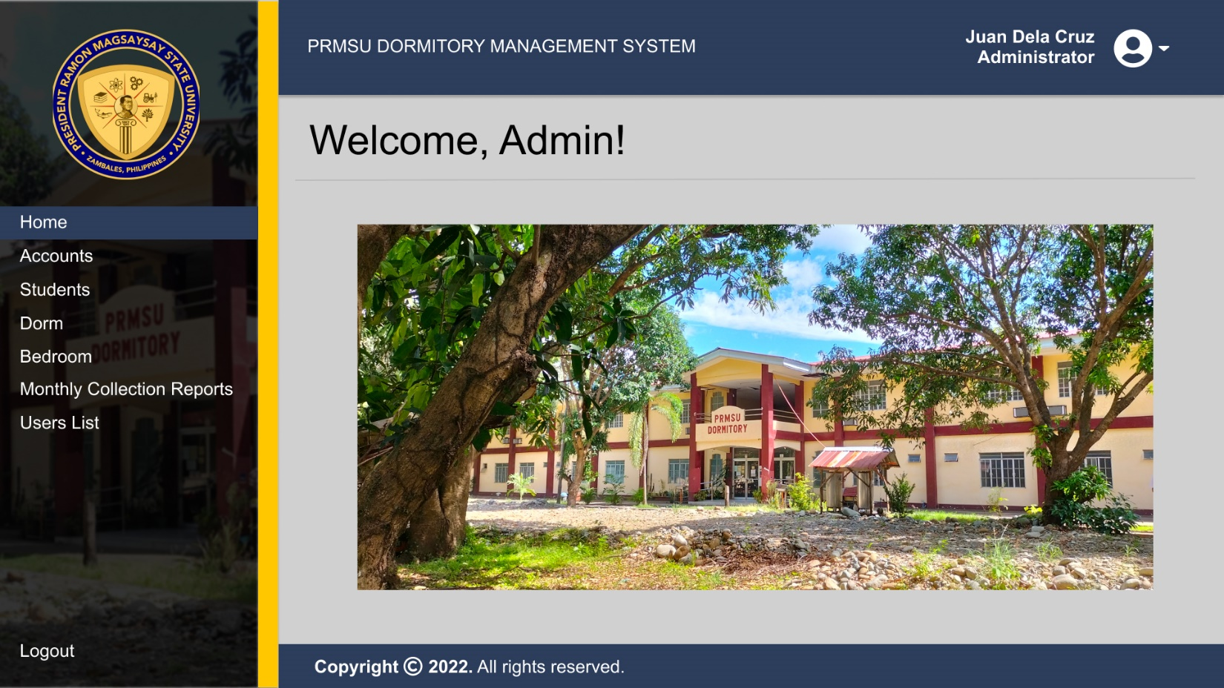

**List of Accounts**

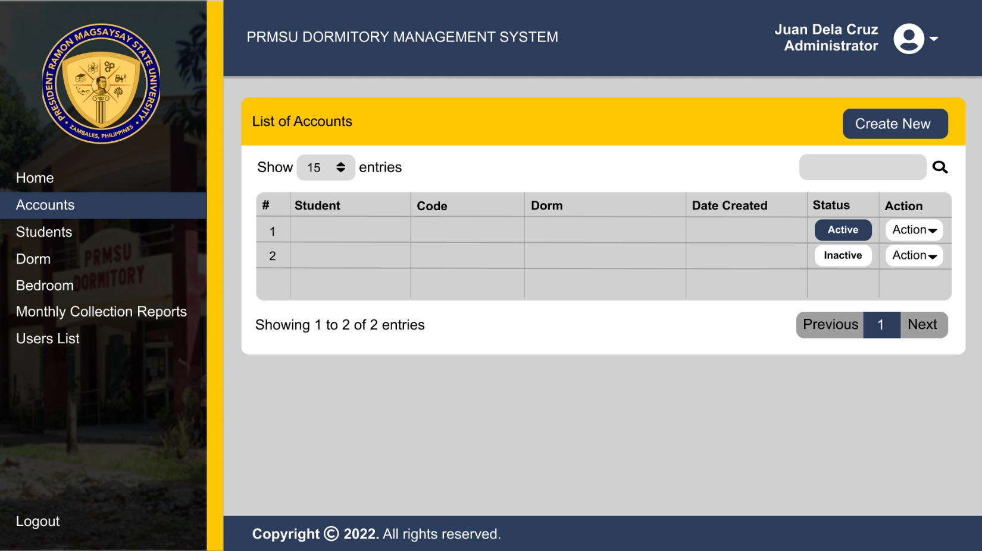

**Managing Accounts**

Create New Account

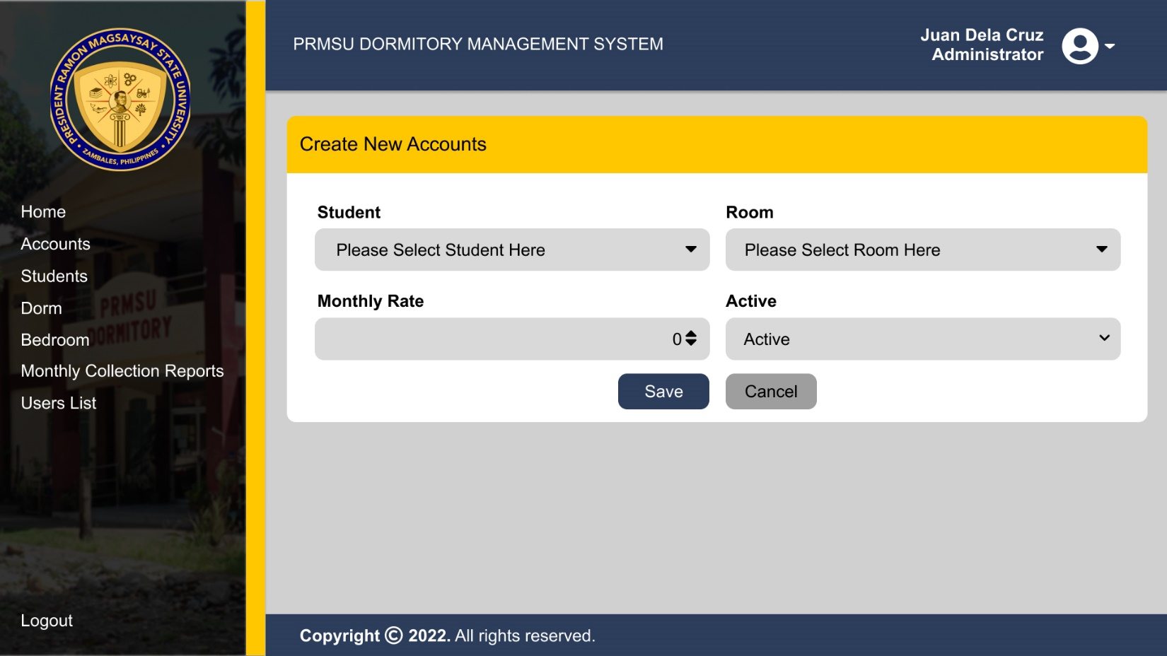

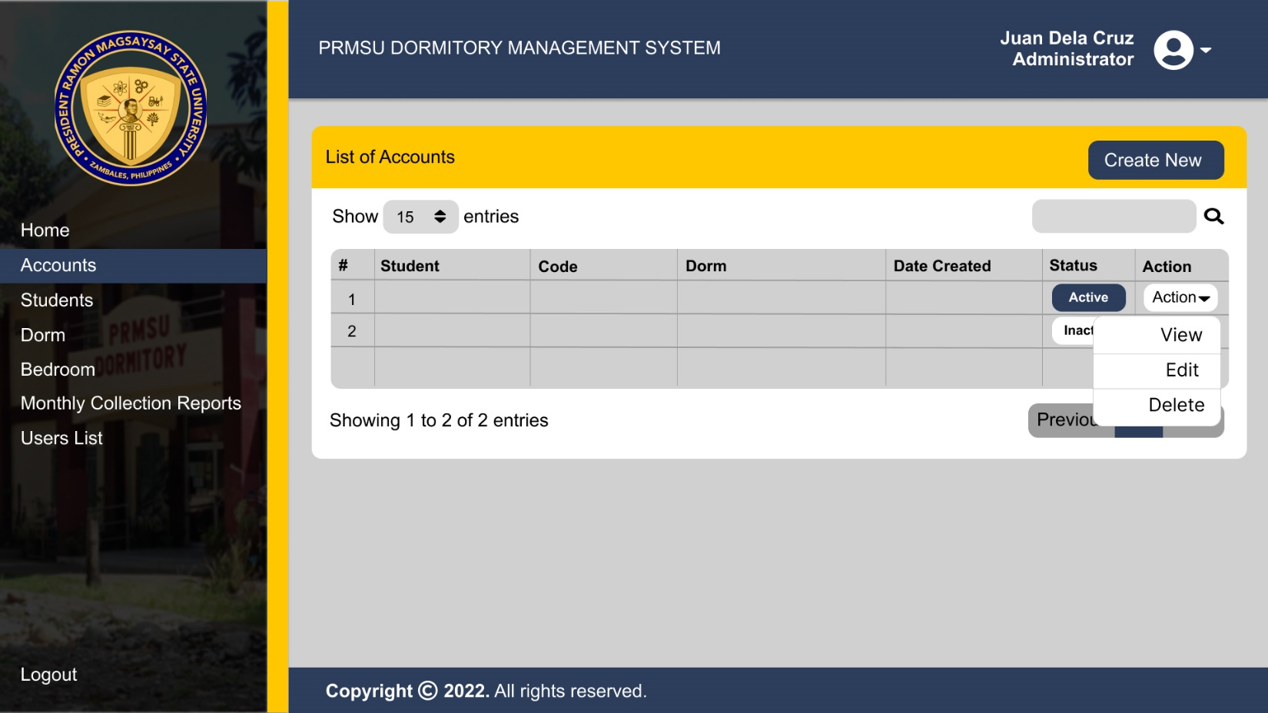

Upon the clicking the dropdown button beside the Action, A menu will pop up displaying a View, Edit, and Delete

Upon Clicking the View Button the user will go to the Account Details, including the Student Information and Dorm Information, after the Dorm Information there are 5 Buttons that are link to other pages of the site which are the Payment History, Add Payment, Edit, Delete, and Back.

Upon Clicking the edit button the user will direct to the Update Account Details.

The Account will be deleted upon clicking the delete button

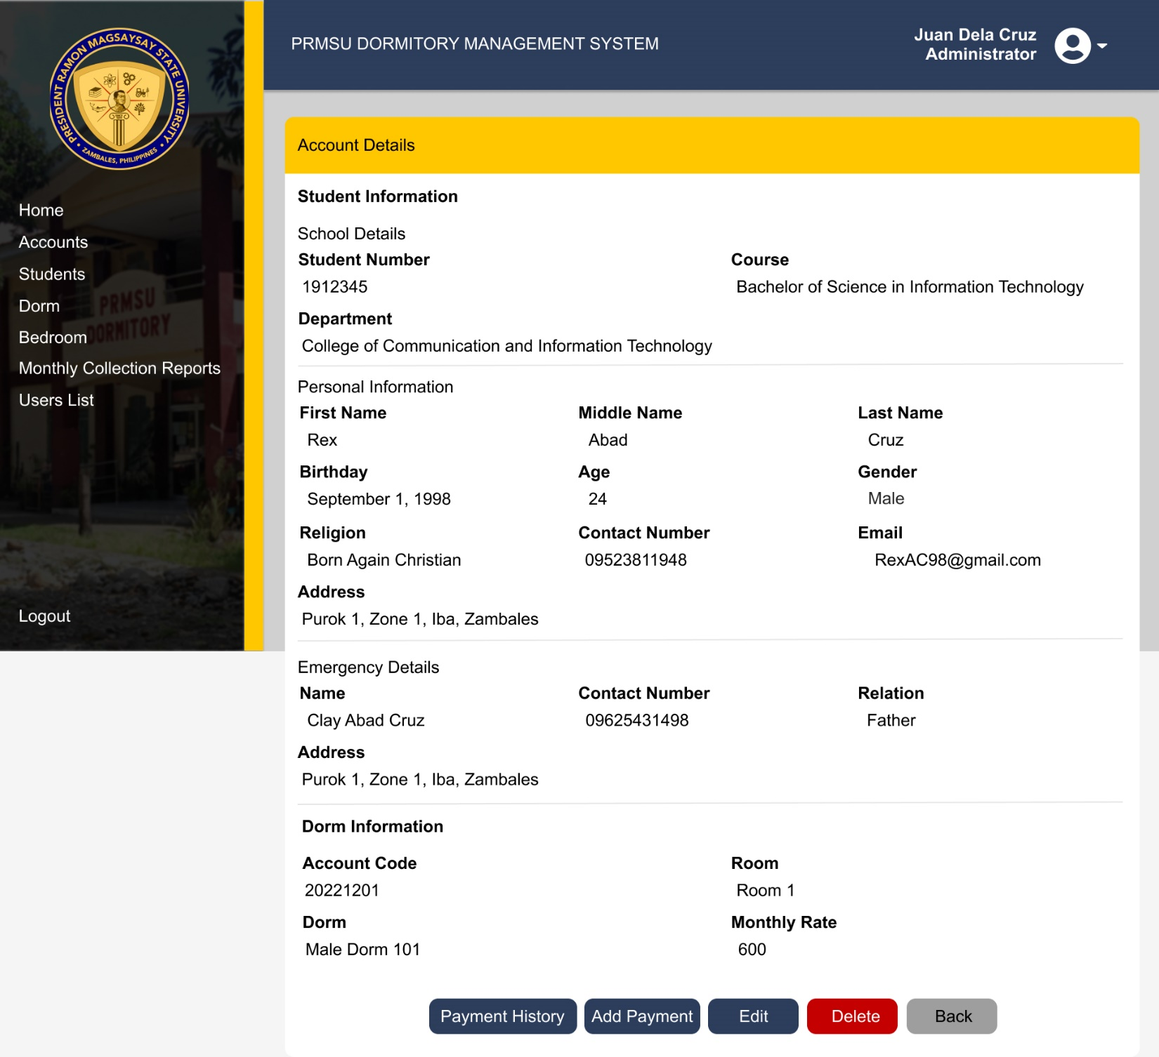

Upon clicking the Payment History button the user will direct to Page that will display the past and recent payments of the students

Upon clicking the Add Payment button the users will direct to the New Payment where the student can add the payment

Upon clicking the edit button the user will direct to Update Account Details

The Account will be deleted upon clicking the delete button

Upon clicking the back button user will directly go back to the list of Accounts page

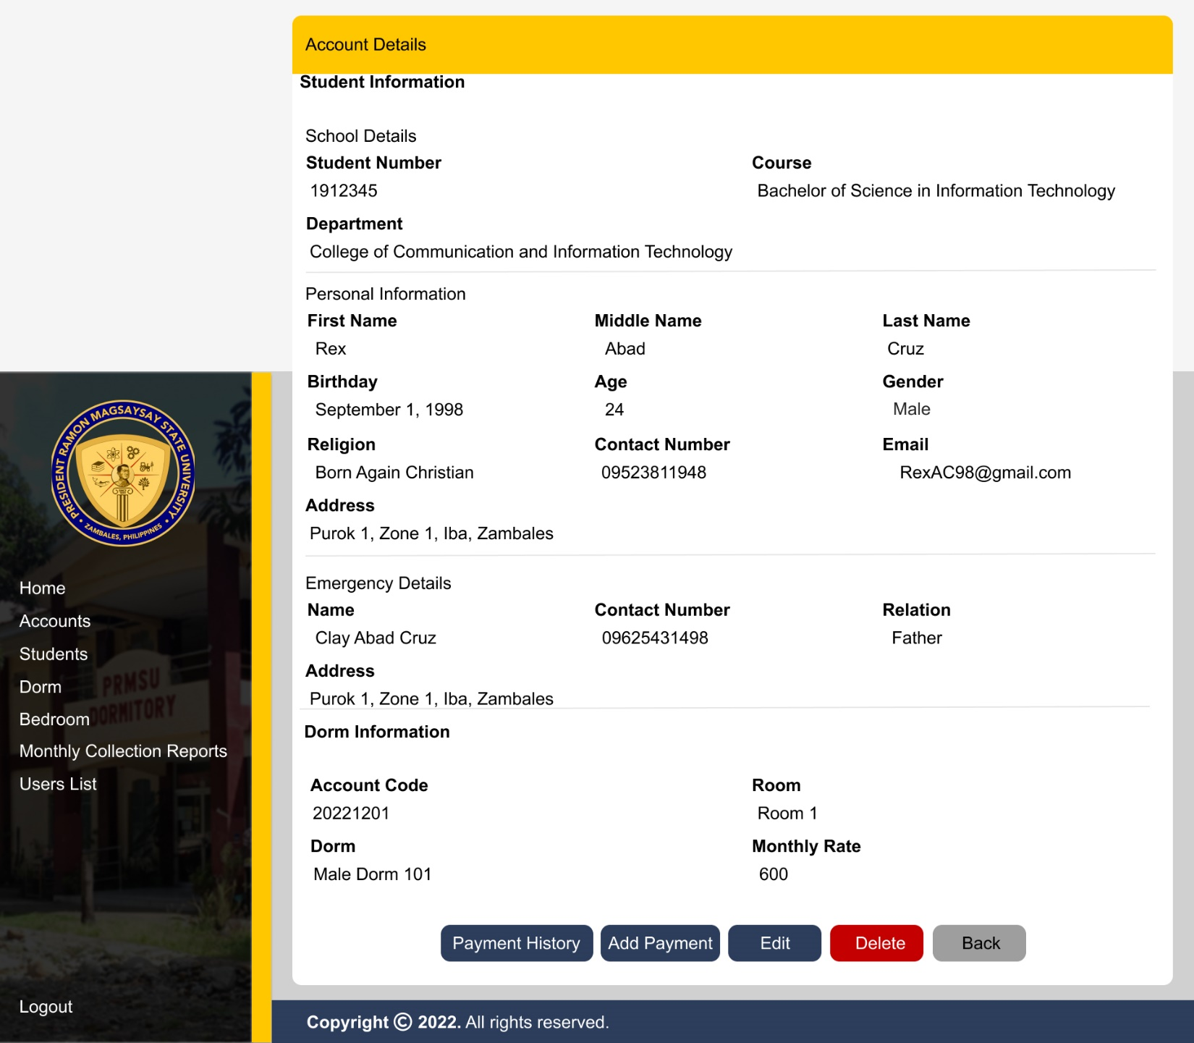

Payment History

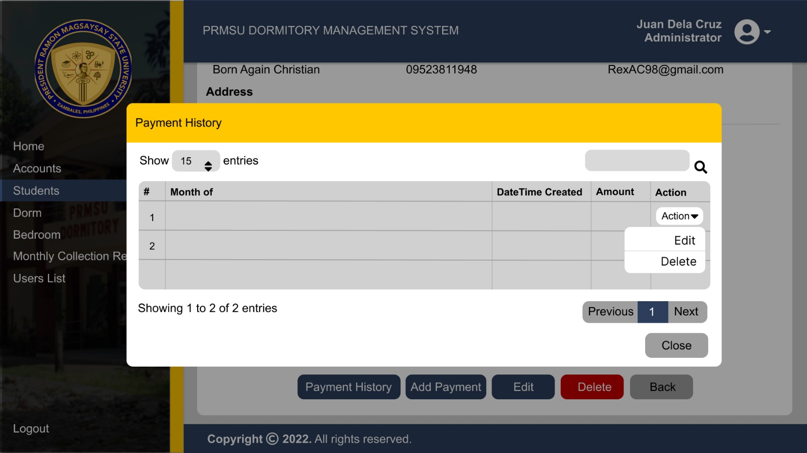

Upon clicking the Payment History Button, their will be a pop up, cover the center part of the screen that enables the user to see the past and recent payments of a specific account

Update Payment Details

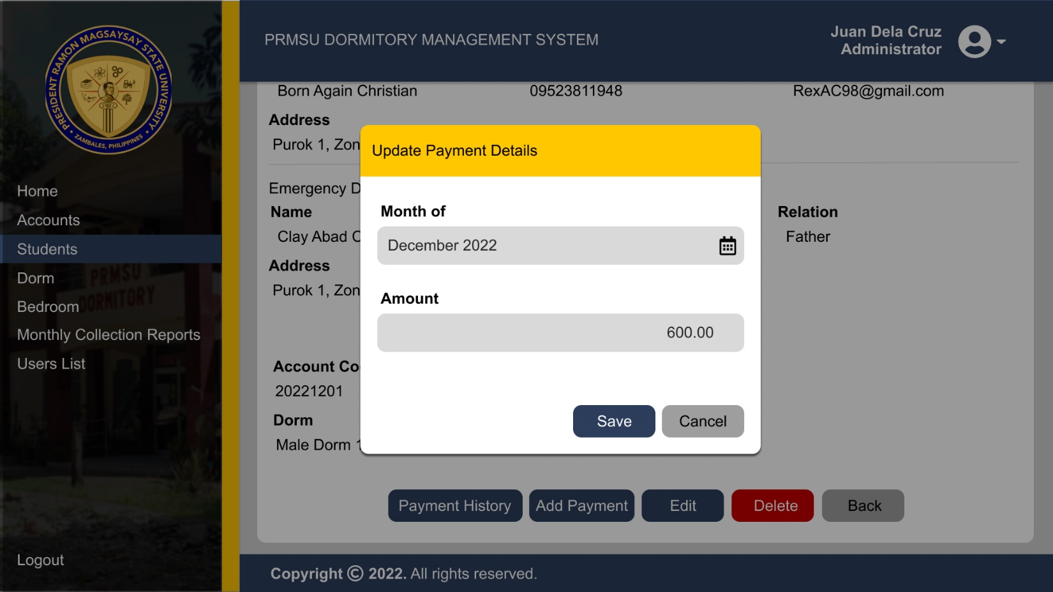

Upon clicking the edit on the dropdown menu, their will be a pop up, cover the center part of the screen that enables to edit the details of the payments.

New Payments

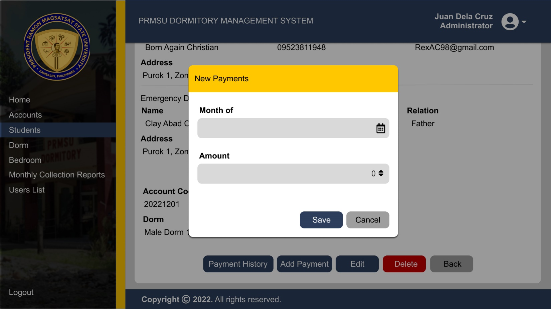

Upon clicking the Add Payment button , their will be a pop up, cover the center part of the screen that enables the user to add a payment transaction.

Update Account Details

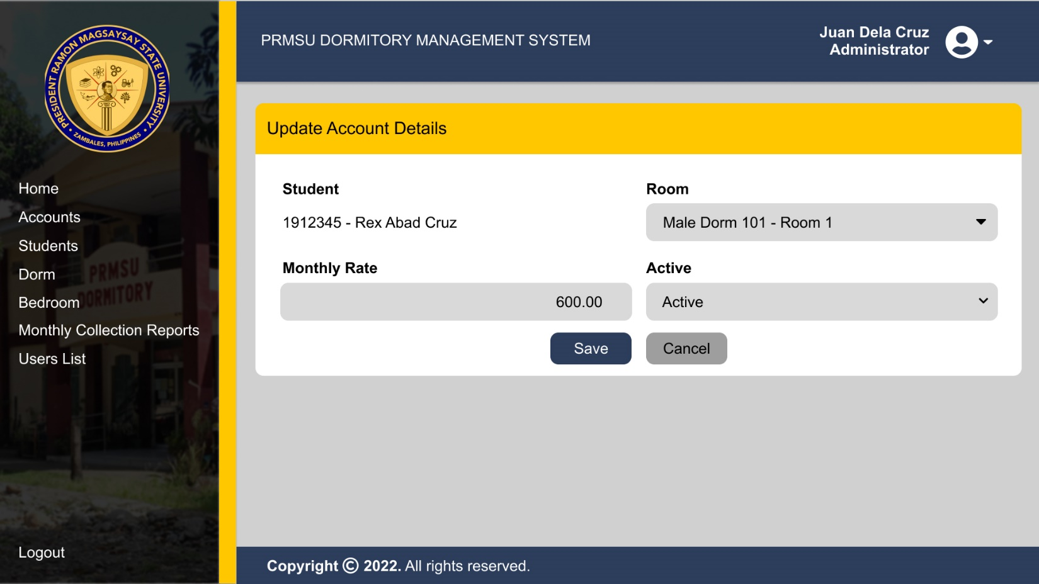

List of Students

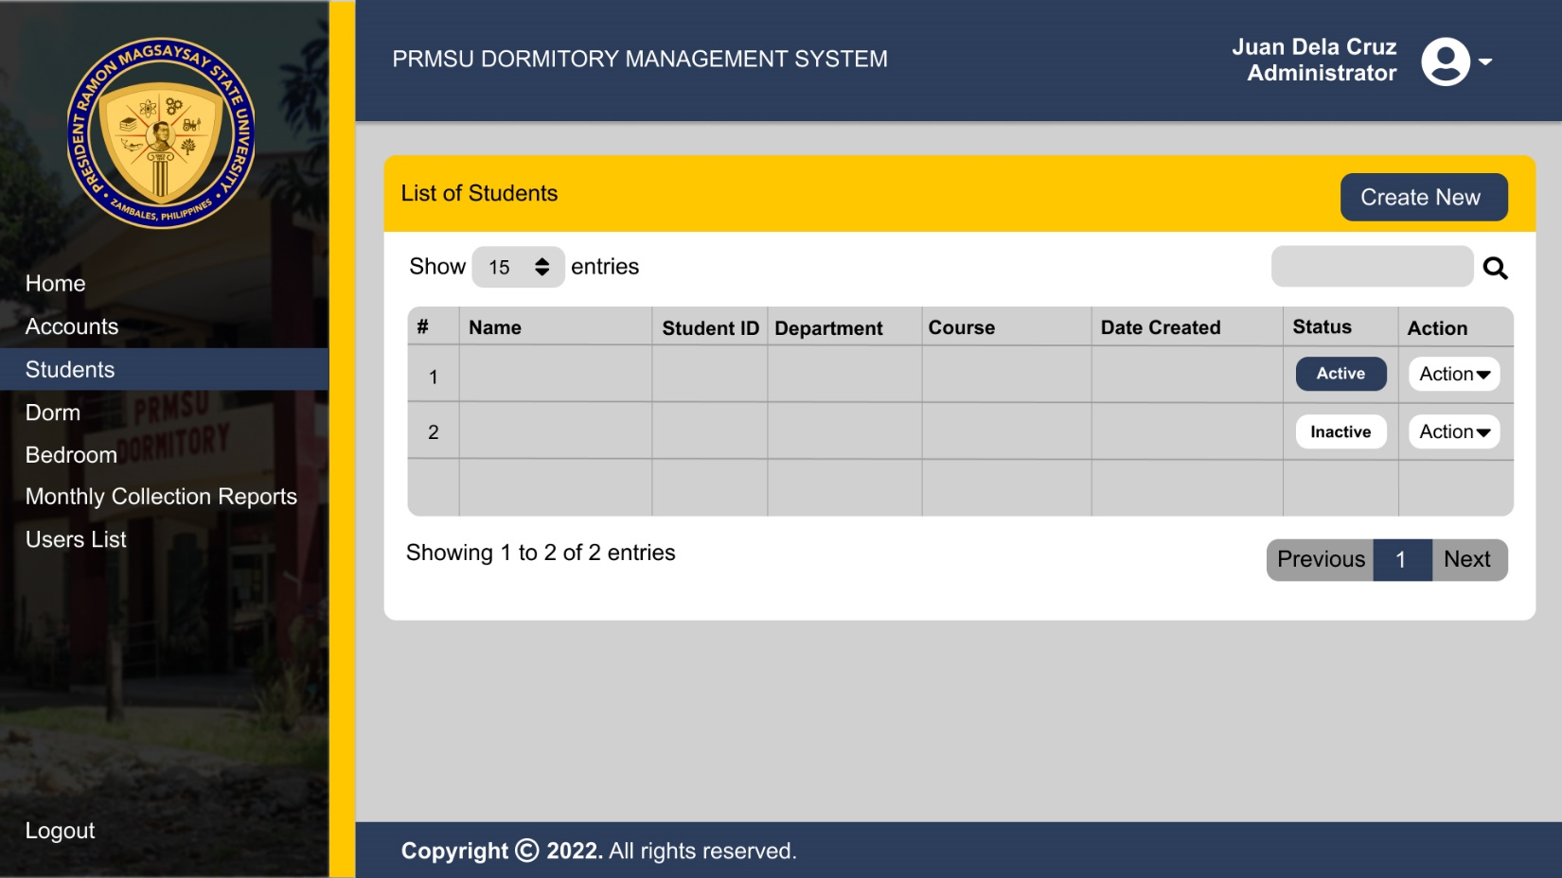

Adding a New Students

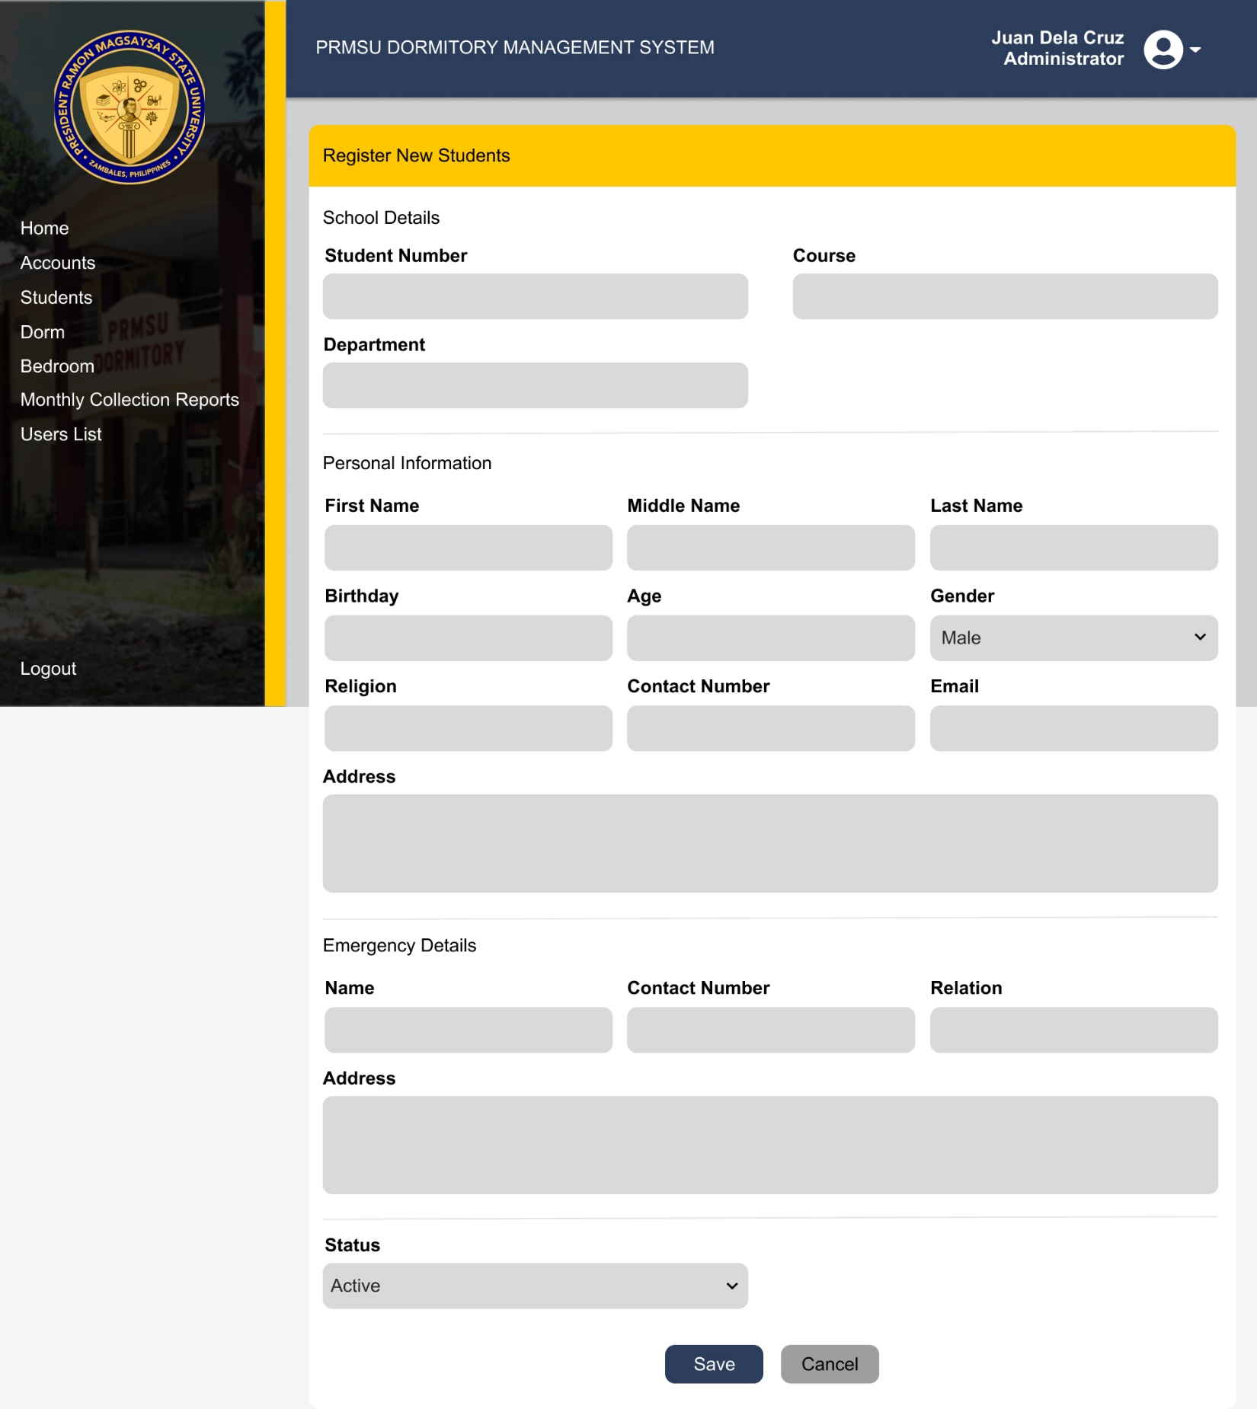

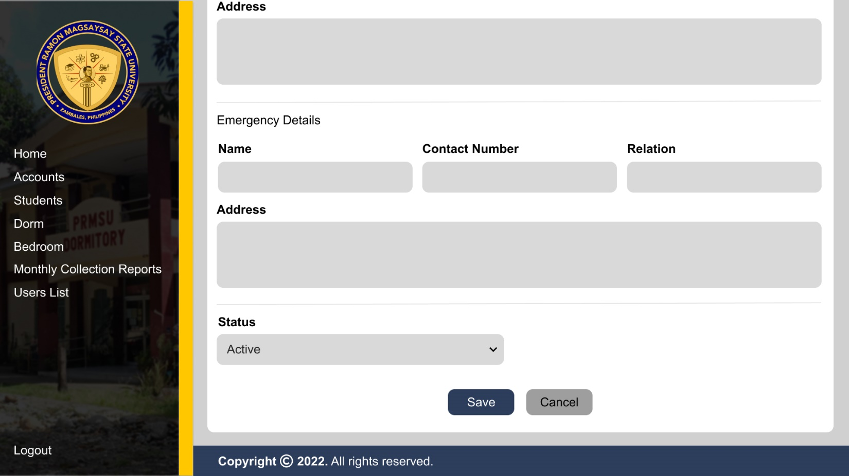

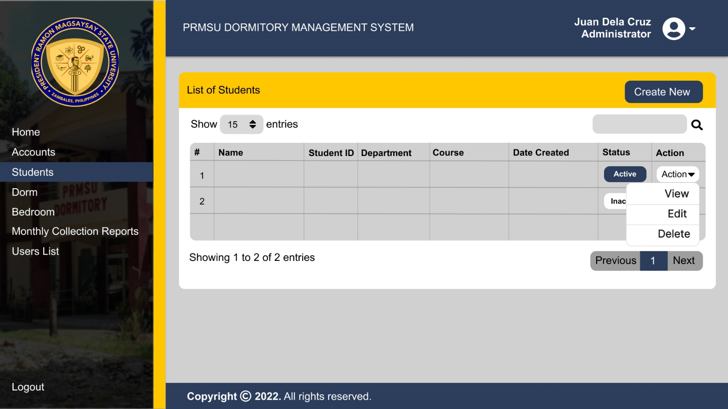

Upon the clicking the dropdown button beside the Action, A menu will pop up displaying a View, Edit, and Delete

Upon Clicking the View Button the user will go to the Students Details, including the School Details, Personal Information, and Emergency Details.

Upon Clicking the edit button the user will direct to the Update Student Details.

The Account will be deleted upon clicking the delete button

View Students Details

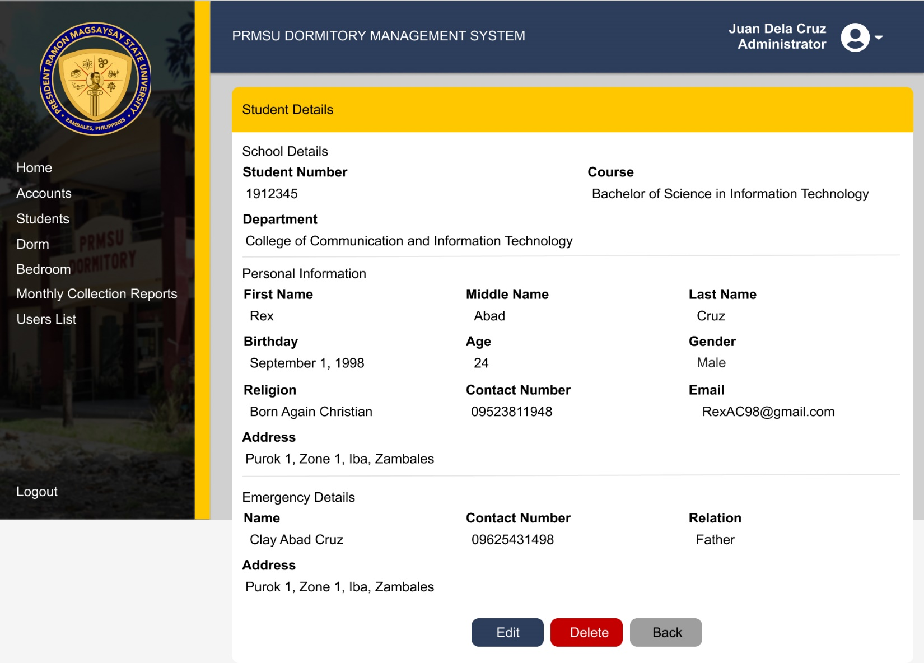

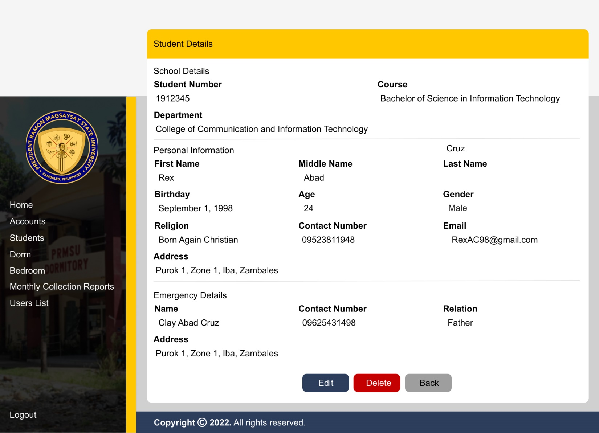

Update Students Details

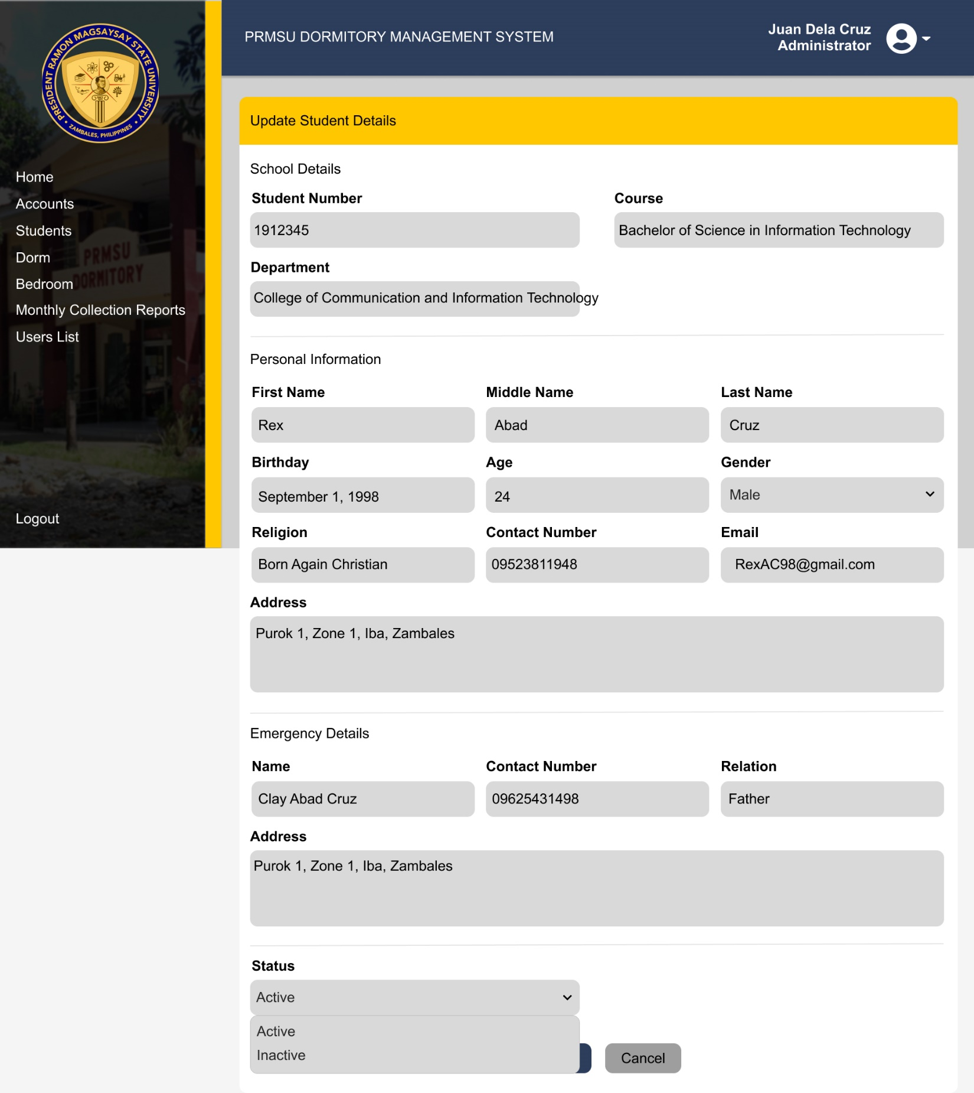

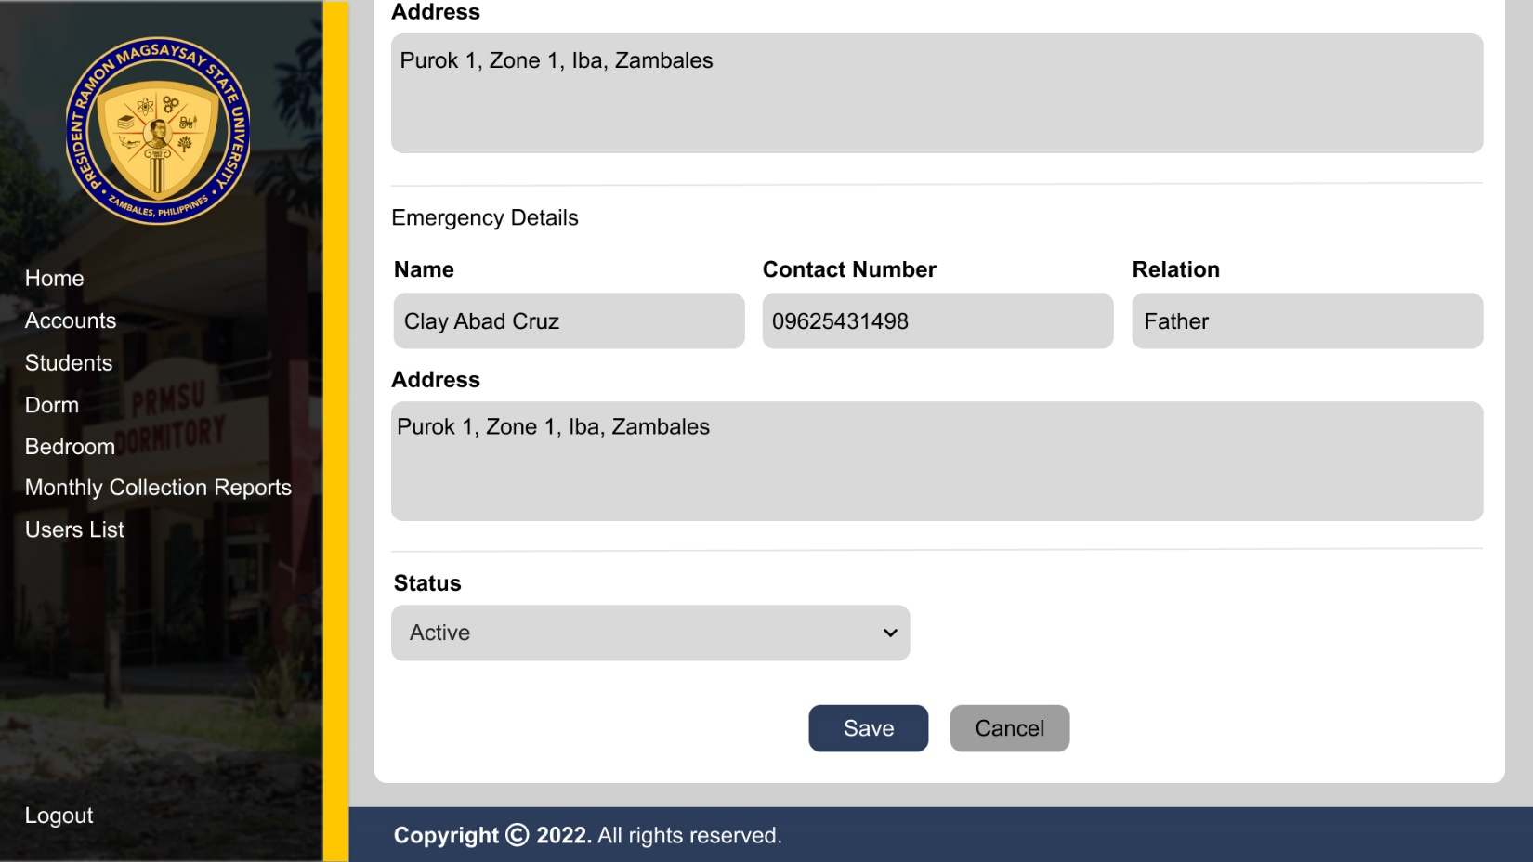

List of Dorms

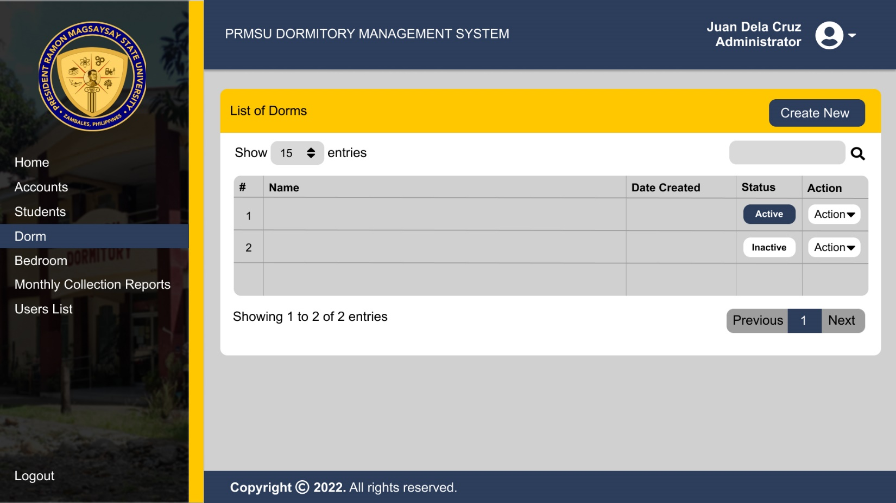

Adding New Dorm

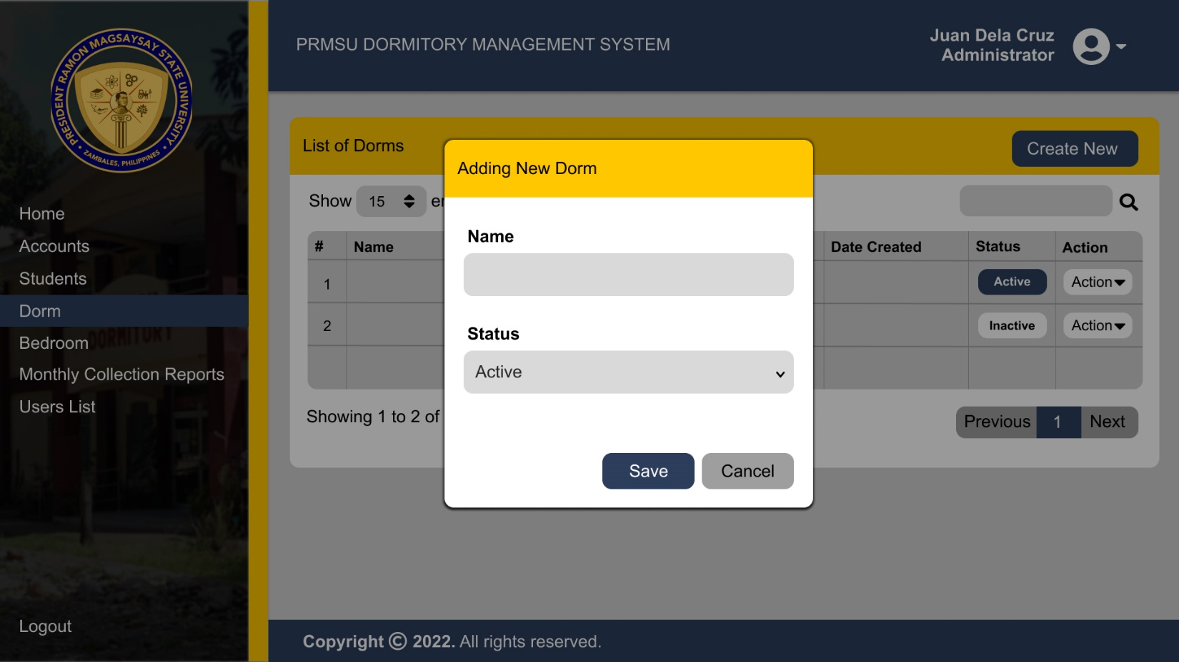

Upon the clicking the Create New button there will be a pop cover the center part that enables the user to a new dorm

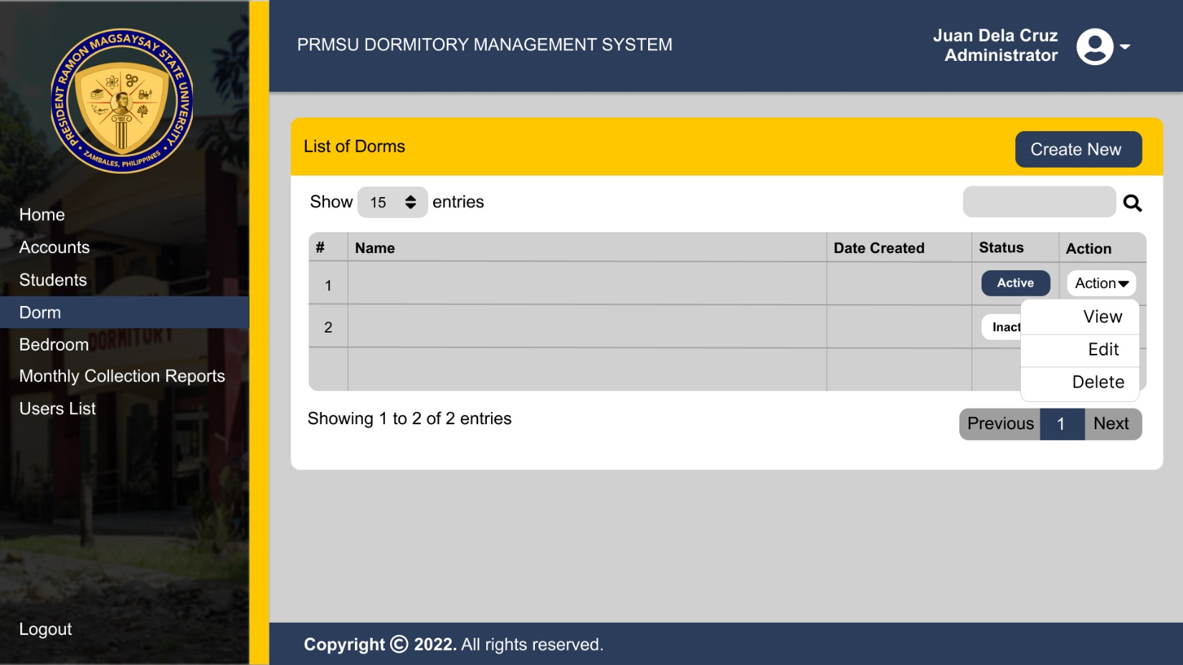

Upon the clicking the dropdown button beside the Action, A menu will pop up displaying a View, Edit, and Delete

View Dorm Details

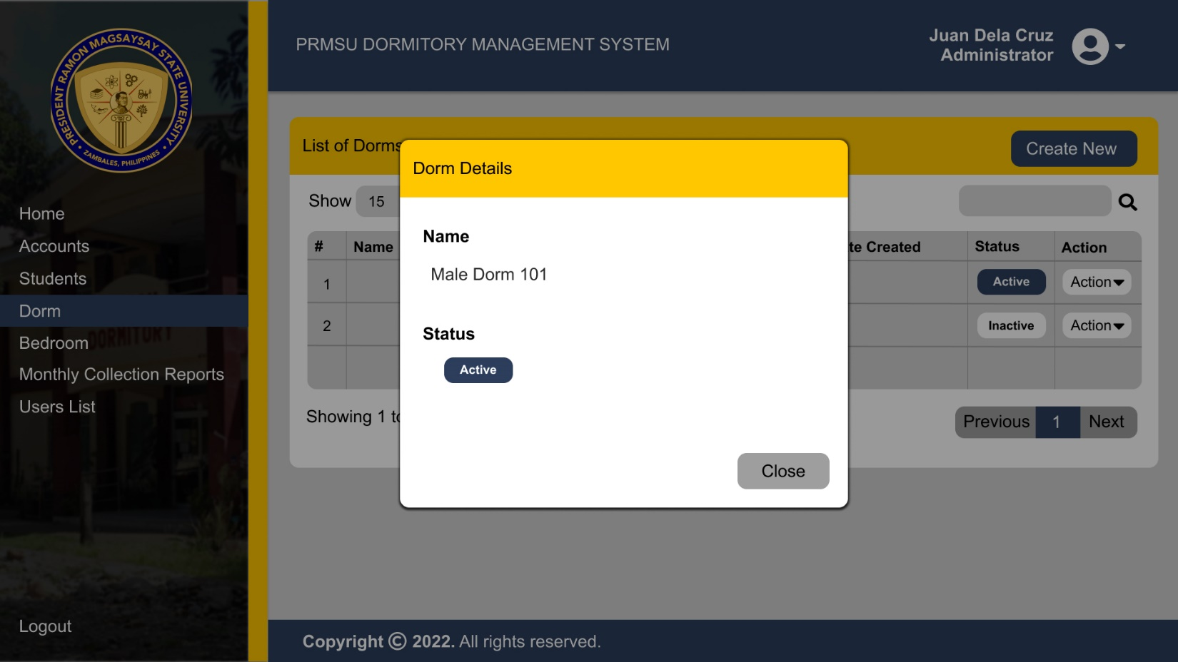

Upon the clicking the view on the dropdown menu there will be a pop up, cover the center part that enables the user to see the details of the dorm that already created.

Update Dorm Details

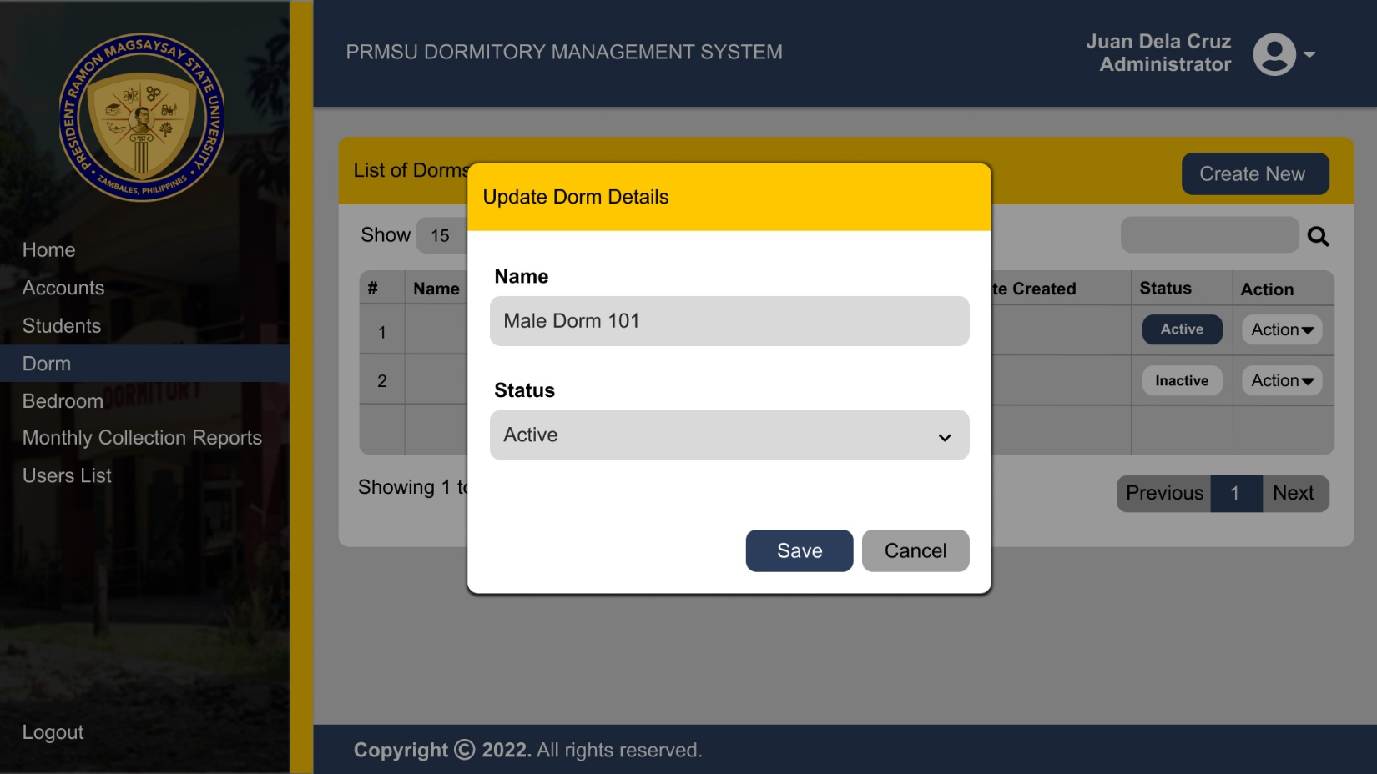

Upon the clicking the edit on the dropdown menu there will be a pop up, cover the center part that enables the user to update the details of the dorm that already created.

List of Bedrooms

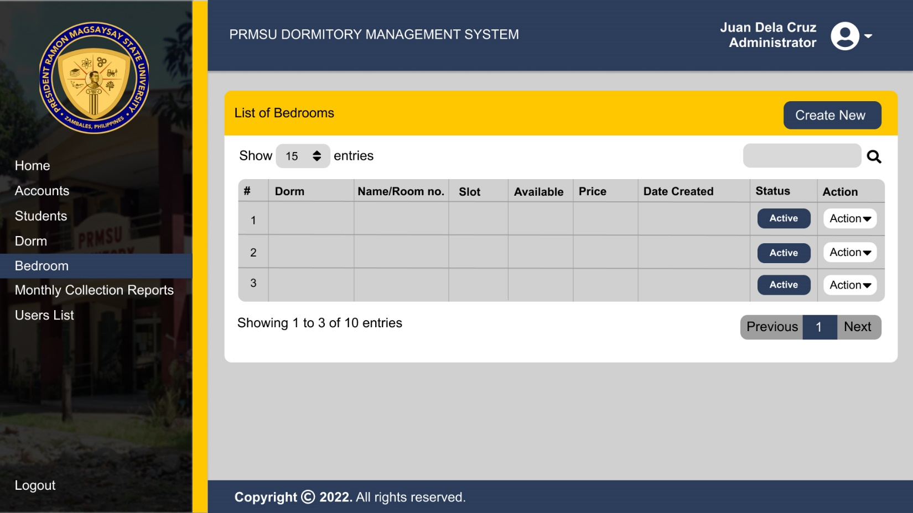

Adding New Room

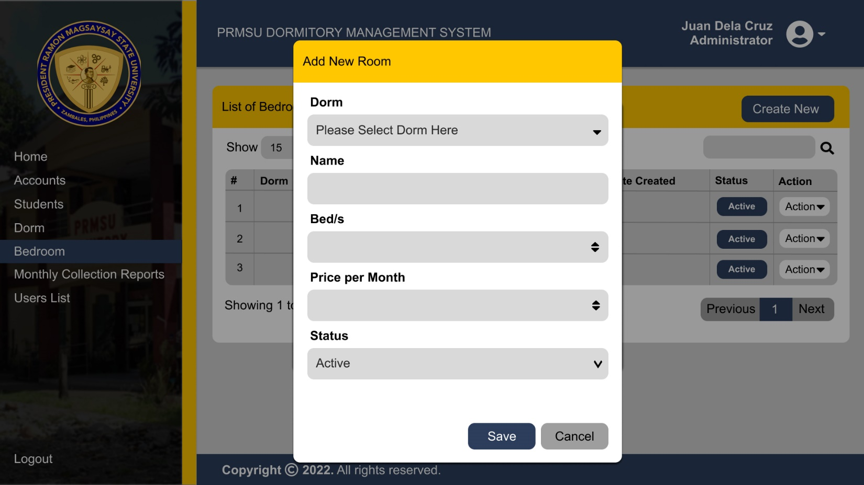

Upon the clicking the Create New button there will be a pop up, cover the center part that enables the user to a add new room on the list.

View Room Details

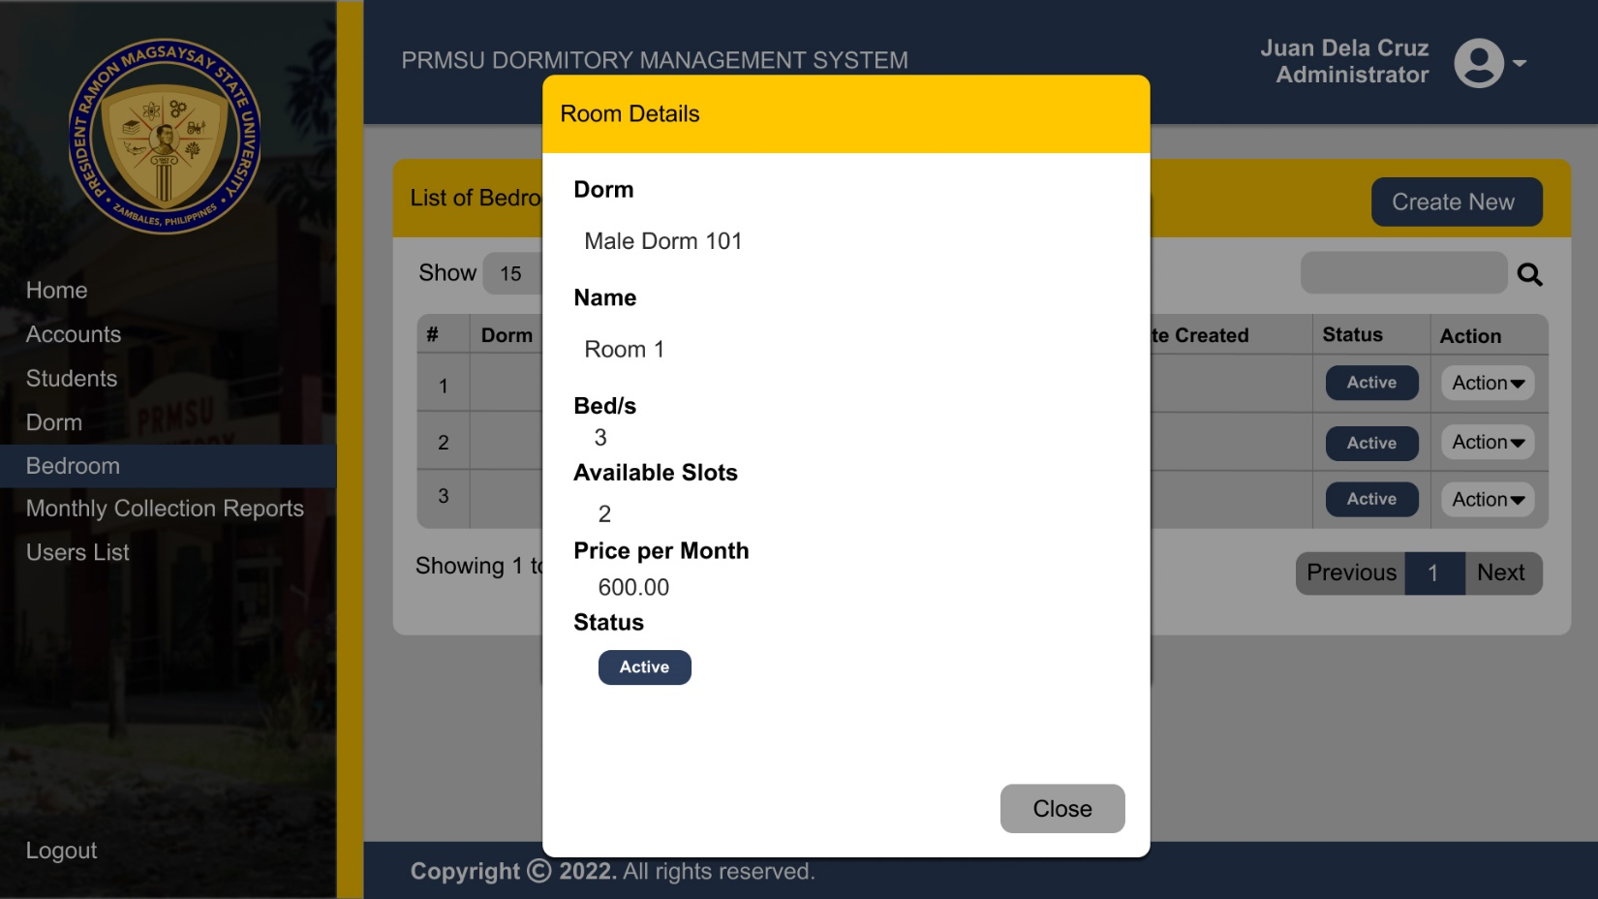

Upon the clicking the view on the dropdown menu there will be a pop up, cover the center part that enables the user to see the details of the room that already created.

Update Room Details

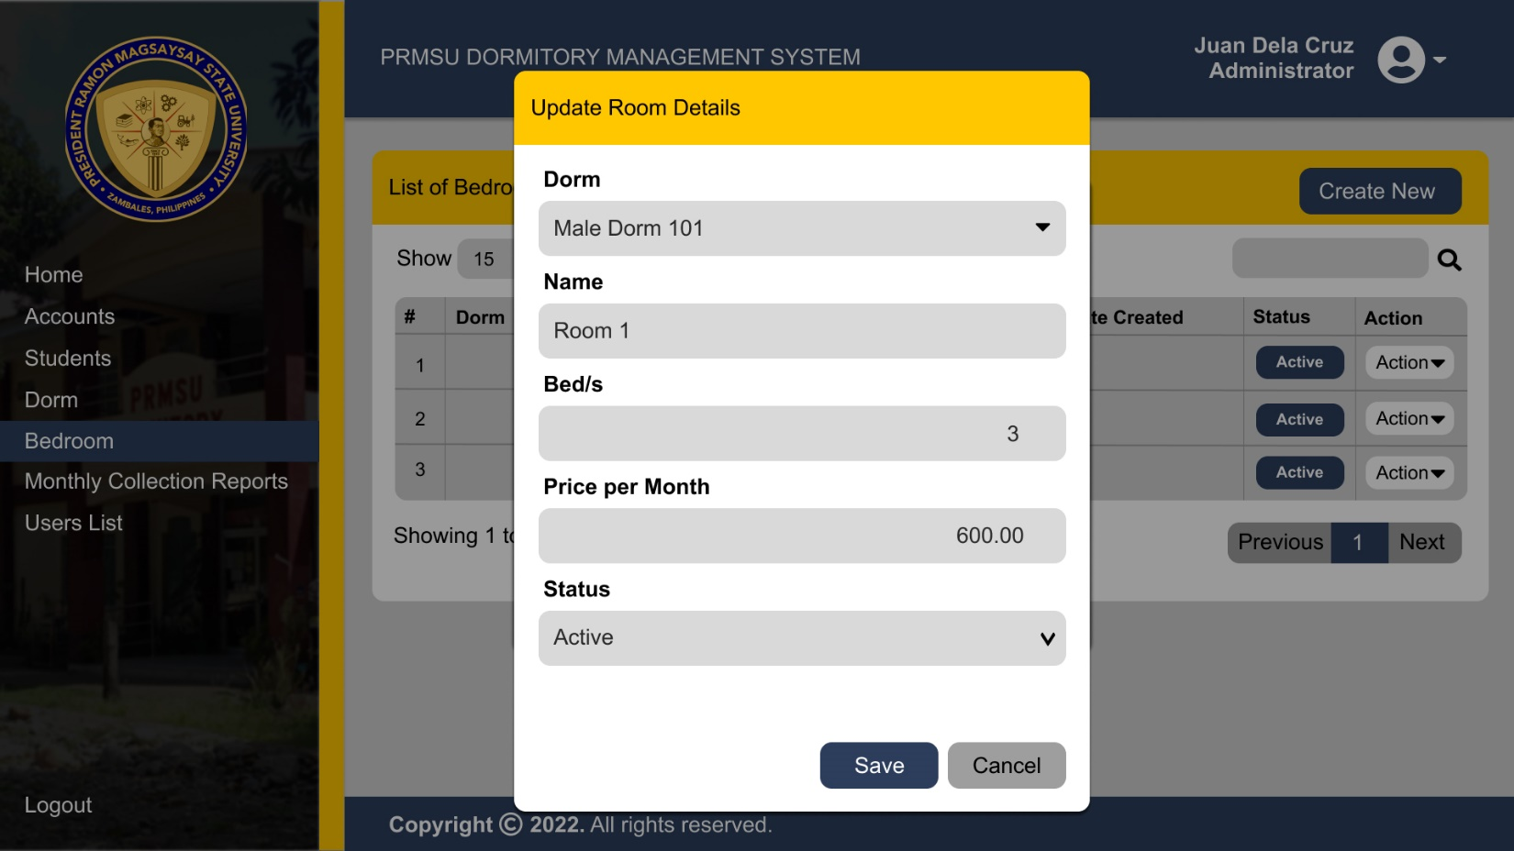

Upon the clicking the edit on the dropdown menu there will be a pop up, cover the center part that enables the user to edit the details of the room that already created.

Monthly Collection Report

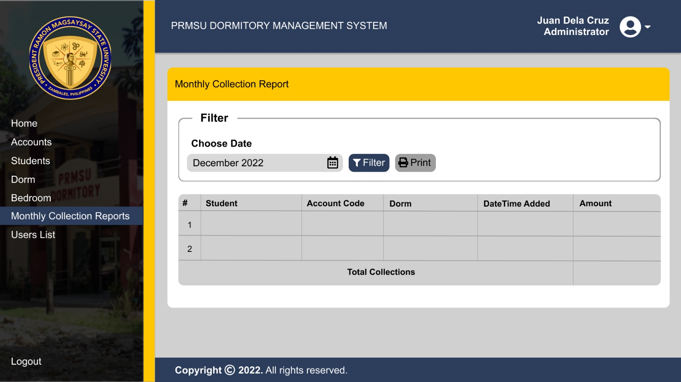

List of Users

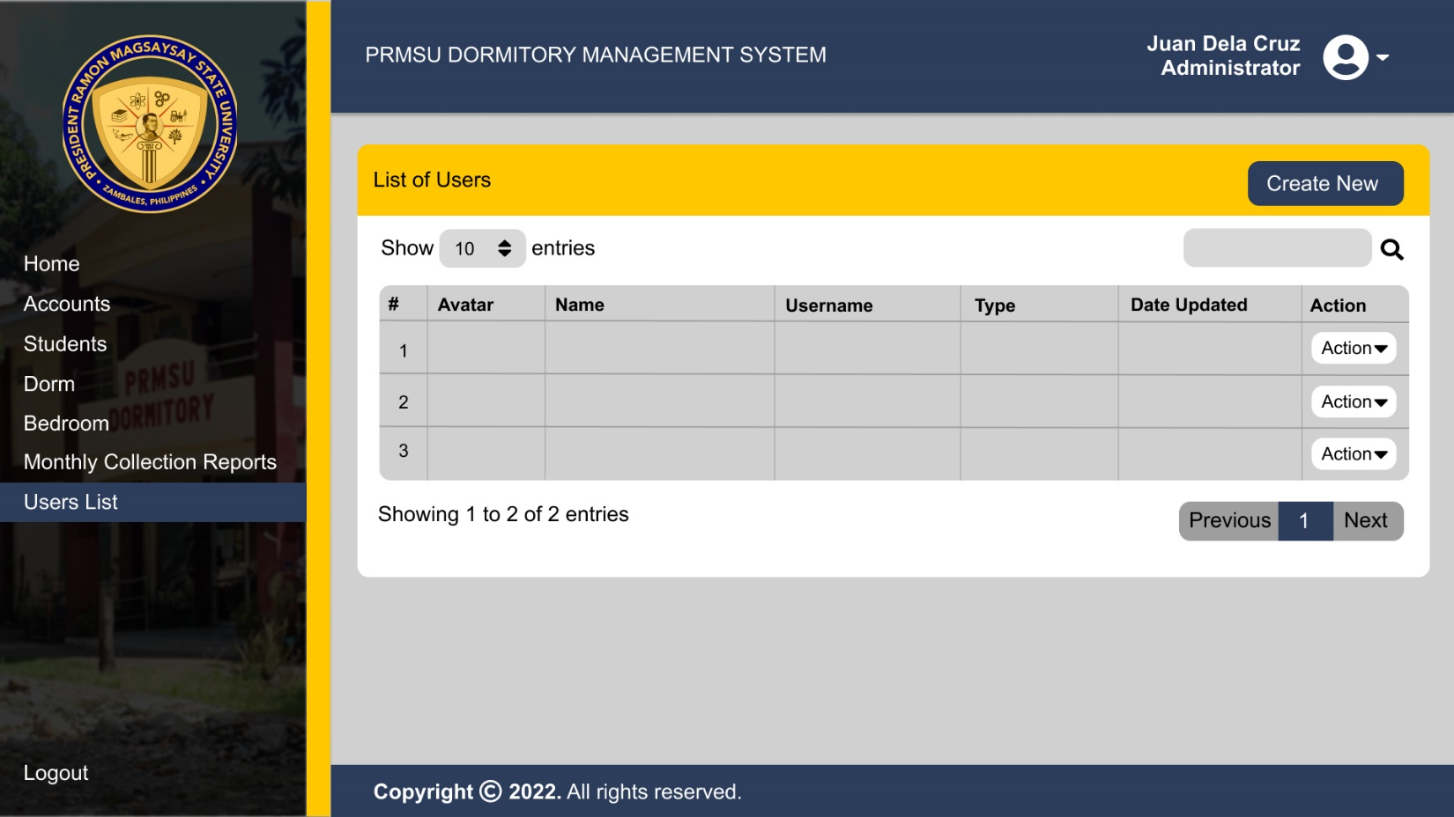

Adding a New User

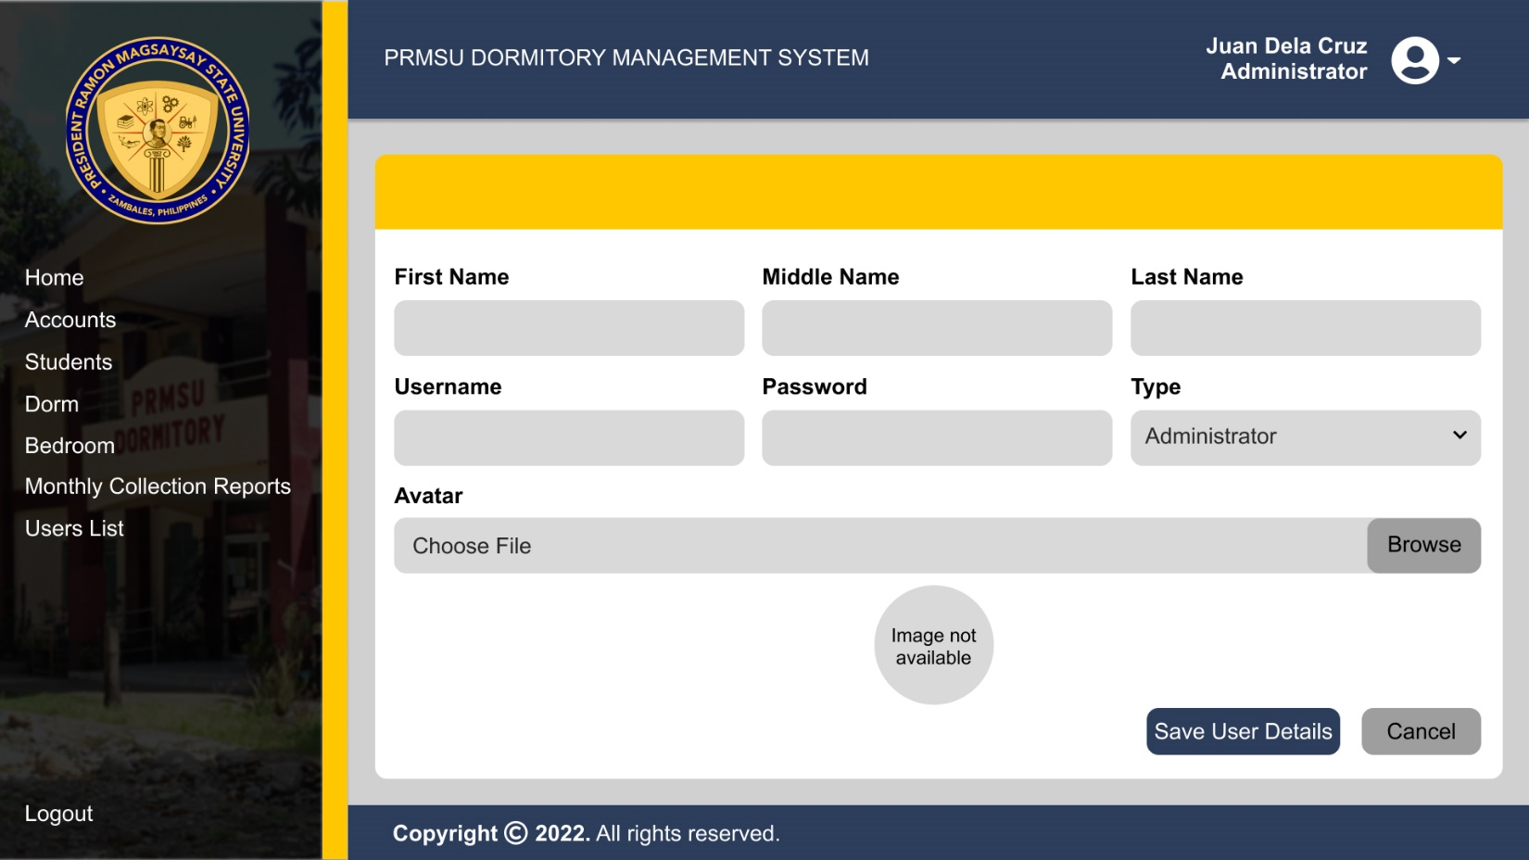

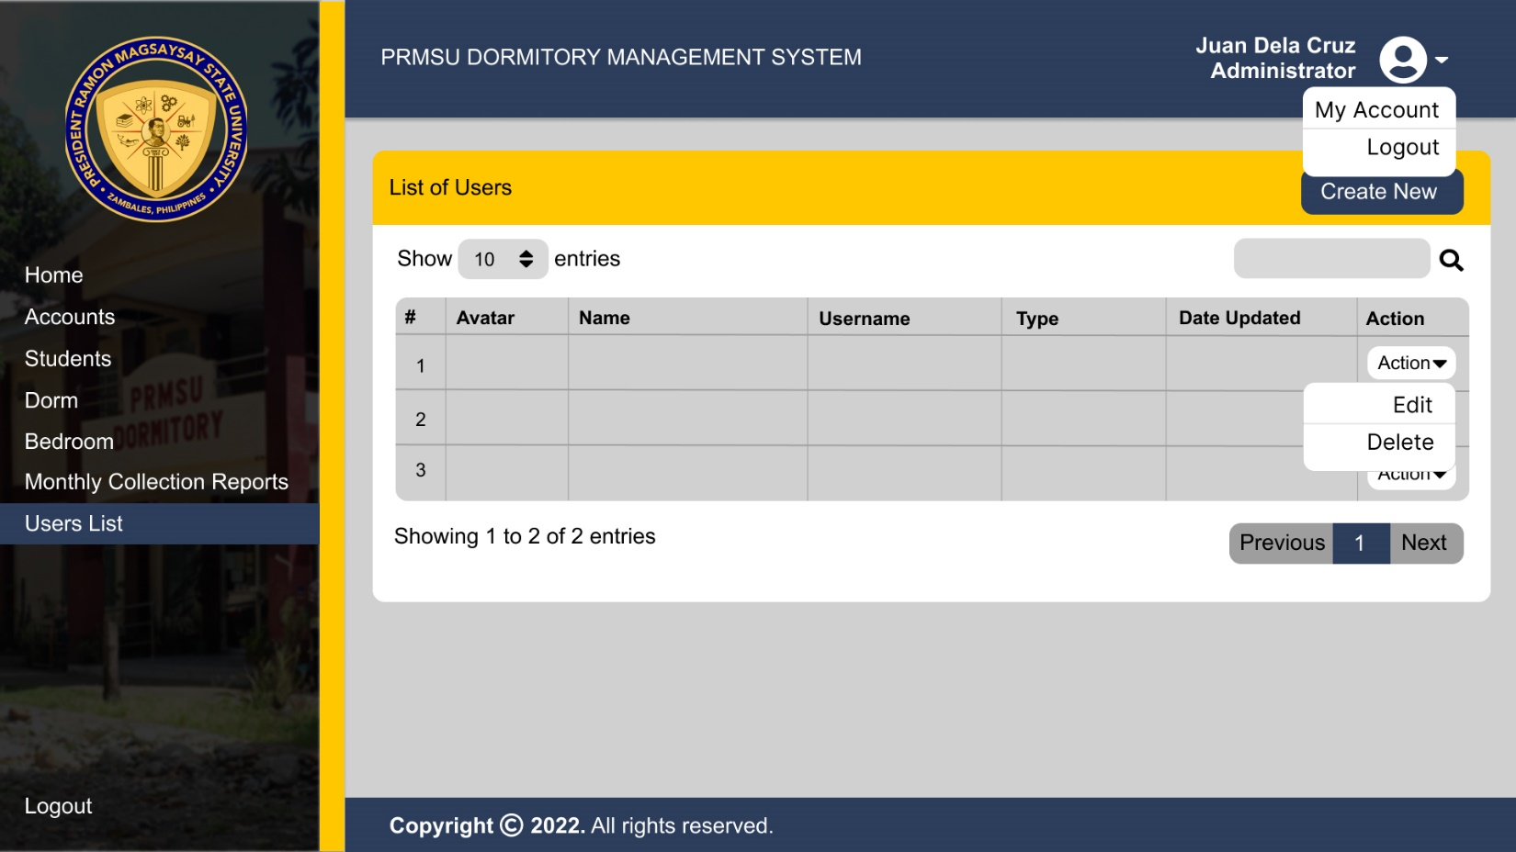

Upon the clicking the edit on the dropdown menu the user will direct to a page that enables to the user to edit users details, such as name, username, password and the users avatar.

Update Users Detail

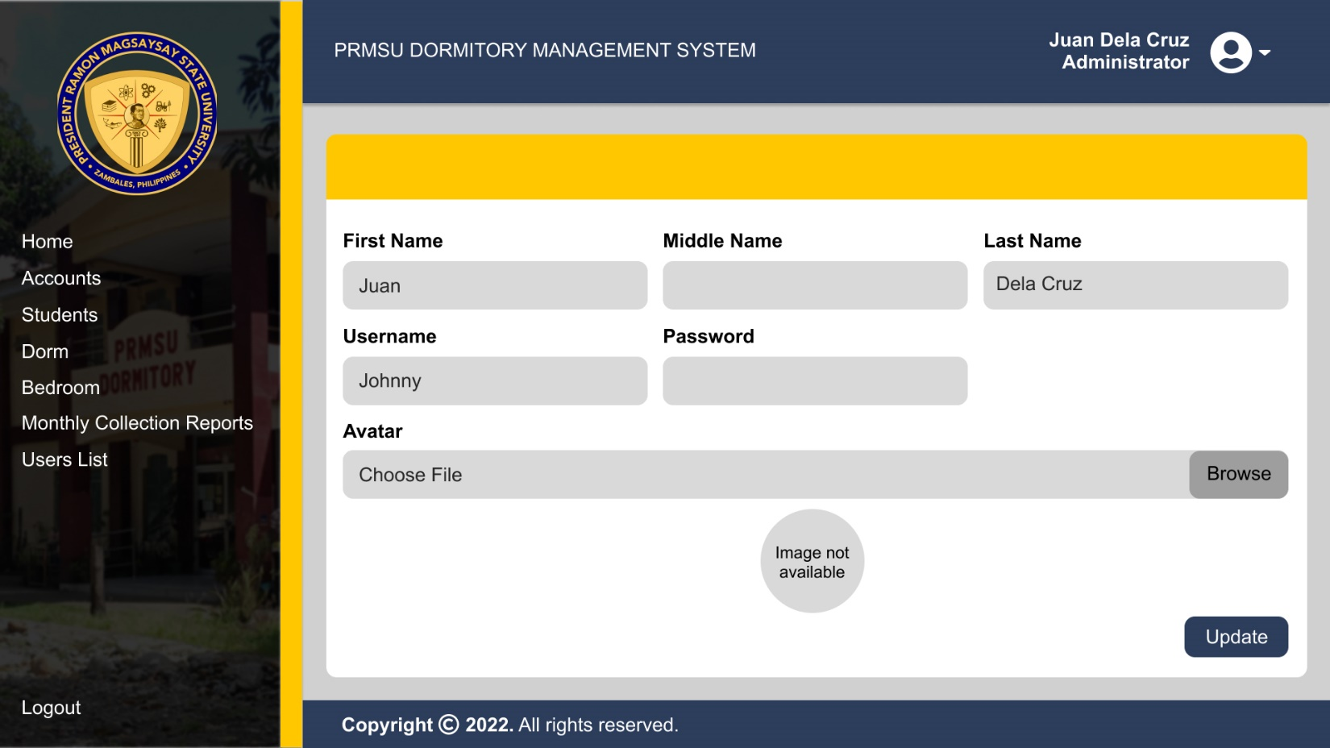

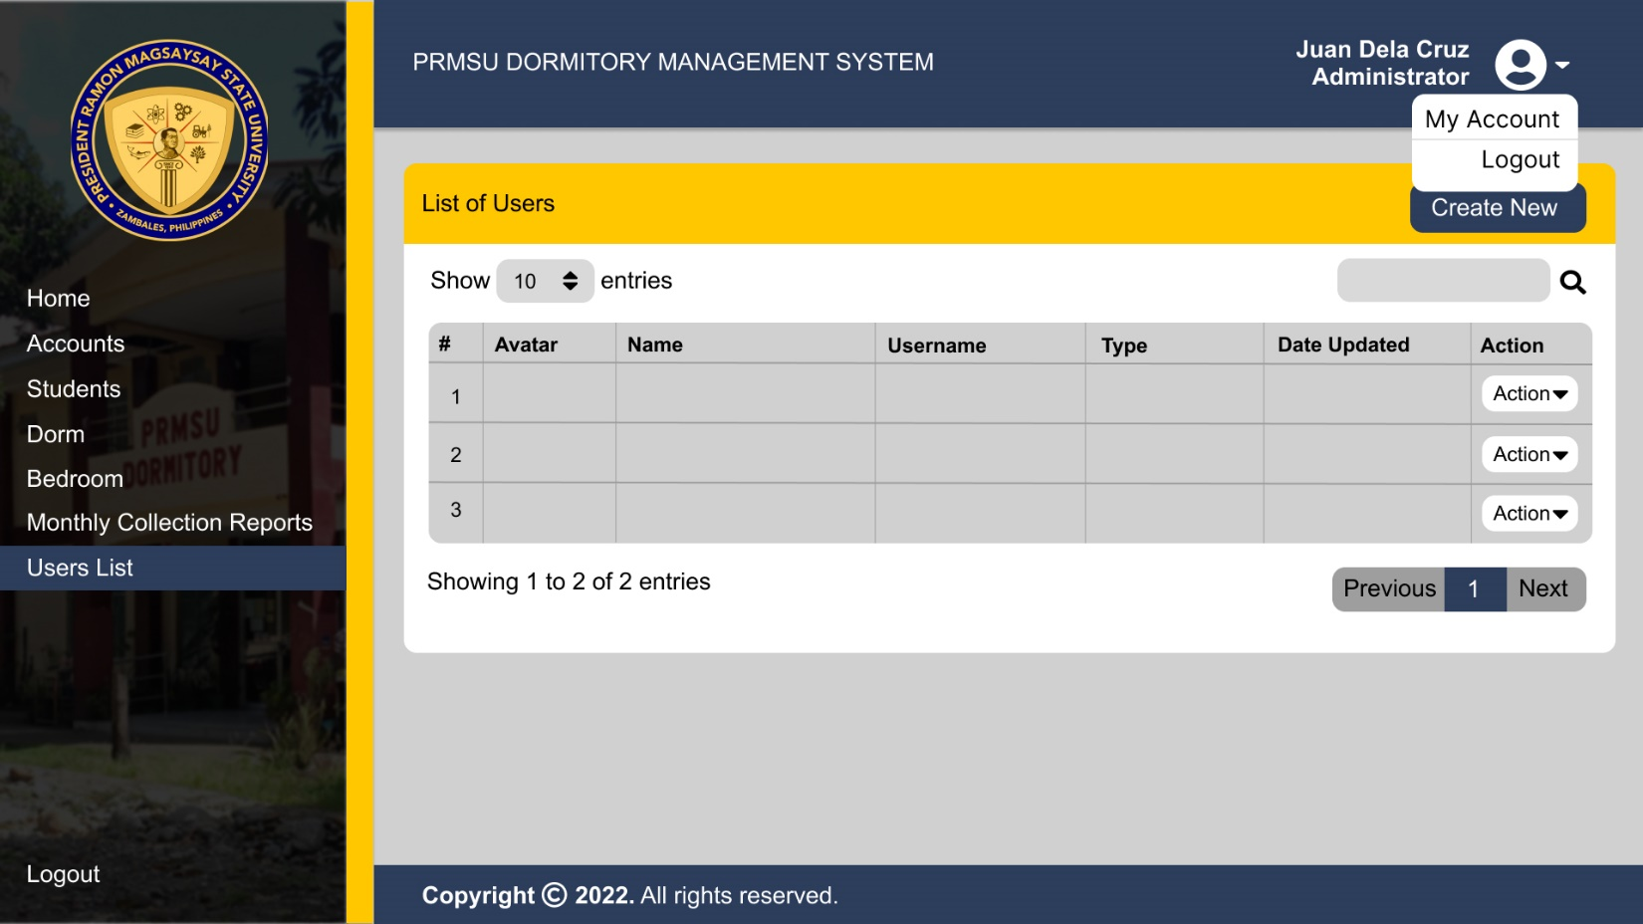

A page where the details of users where can be updated can also be access through clicking the My Account on the dropdown menu near at the users avatar/icon.